Q) What are different oops concept in java?
Ans) OOPs stands for Object Oriented Programming. The concepts in oops are similar to any other programming languages. Basically, it is program agnostic.
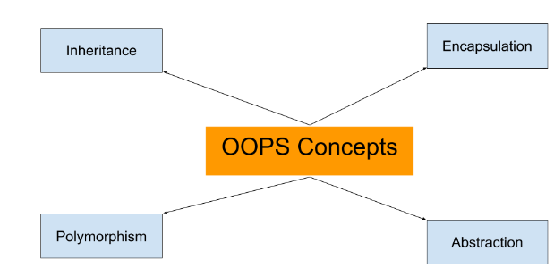
In this page, we will learn about basics of OOPs. Object Oriented Programming is a paradigm that provides many concepts such as inheritance, data binding, polymorphism etc.
Simula is considered as the first object-oriented programming language. The programming paradigm where everything is represented as an object, is known as truly object-oriented programming language.
Smalltalk is considered as the first truly object-oriented programming language.

OOPs (Object Oriented Programming System)
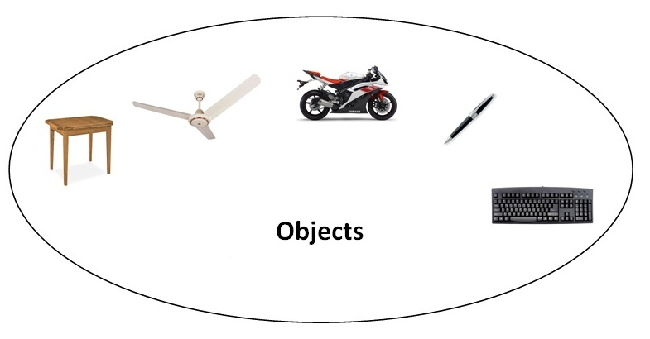Object means a real word entity such as pen, chair, table etc.Object-Oriented Programming is a methodology or paradigm to design a program using classes and objects. It simplifies the software development and maintenance by providing some concepts:
- Object
- Class
- Inheritance
- Polymorphism
- Abstraction
- Encapsulation

Object
Any entity that has state and behavior is known as an object. For example: chair, pen, table, keyboard, bike etc. It can be physical and logical.

Class
Collection of objects is called class. It is a logical entity.

Inheritance
When one object acquires all the properties and behaviours of parent object i.e. known as inheritance. It provides code reusability. It is used to achieve runtime polymorphism.


Polymorphism
When one task is performed by different ways i.e. known as polymorphism. For example: to convince the customer differently, to draw something e.g. shape or rectangle etc.
In java, we use method overloading and method overriding to achieve polymorphism.
Another example can be to speak something e.g. cat speaks meaw, dog barks woof etc.

Abstraction
Hiding internal details and showing functionality is known as abstraction. For example: phone call, we don't know the internal processing.
In java, we use abstract class and interface to achieve abstraction.


Encapsulation
Binding (or wrapping) code and data together into a single unit is known as encapsulation. For example: capsule, it is wrapped with different medicines.
A java class is the example of encapsulation. Java bean is the fully encapsulated class because all the data members are private here

What are the different ways to create an object in Java?
There are many ways to create an object in java. They are:
- By new keyword
- By newInstance() method
- By clone() method
- By factory method etc.
We will learn, these ways to create the object later.

Annonymous object
Annonymous simply means nameless.An object that have no reference is known as annonymous object.
If you have to use an object only once, annonymous object is a good approach.
- class Calculation{

- void fact(int n){
- int fact=1;
- for(int i=1;i<=n;i++){
- fact=fact*i;
- }
- System.out.println("factorial is "+fact);
- }

- public static void main(String args[]){
- new Calculation().fact(5);//calling method with annonymous object
- }
- }
Output:Factorial is 120
.

Method Overloading in Java
- Different ways to overload the method
- By changing the no. of arguments
- By changing the datatype
- Why method overloading is not possible by changing the return type
- Can we overload the main method
- method overloading with Type Promotion
If a class have multiple methods by same name but different parameters, it is known as Method Overloading.
If we have to perform only one operation, having same name of the methods increases the readability of the program.
Suppose you have to perform addition of the given numbers but there can be any number of arguments, if you write the method such as a(int,int) for two parameters, and b (int,int,int) for three parameters then it may be difficult for you as well as other programmers to understand the behavior of the method because its name differs. So, we perform method overloading to figure out the program quickly.


Advantage of method overloading?
Method overloading increases the readability of the program.

Different ways to overload the method
There are two ways to overload the method in java
- By changing number of arguments
- By changing the data type

) Example of Method Overloading by changing the no. of arguments
In this example, we have created two overloaded methods, first sum method performs addition of two numbers and second sum method performs addition of three numbers.
- class Calculation{
- void sum(int a,int b){System.out.println(a+b);}
- void sum(int a,int b,int c){System.out.println(a+b+c);}

- public static void main(String args[]){
- Calculation obj=new Calculation();
- obj.sum(10,10,10);
- obj.sum(20,20);

- }
- }
Test it Now
Output:30
40

2) Example of Method Overloading by changing data type of argument
In this example, we have created two overloaded methods that differs in data type. The first sum method receives two integer arguments and second sum method receives two double arguments.
- class Calculation2{
- void sum(int a,int b){System.out.println(a+b);}
- void sum(double a,double b){System.out.println(a+b);}

- public static void main(String args[]){
- Calculation2 obj=new Calculation2();
- obj.sum(10.5,10.5);
- obj.sum(20,20);

- }
- }
Test it Now
Output:21.0
40

Que) Why Method Overloaing is not possible by changing the return type of method?
In java, method overloading is not possible by changing the return type of the method because there may occur ambiguity. Let's see how ambiguity may occur:
because there was problem:
- class Calculation3{
- int sum(int a,int b){System.out.println(a+b);}
- double sum(int a,int b){System.out.println(a+b);}

- public static void main(String args[]){
- Calculation3 obj=new Calculation3();
- int result=obj.sum(20,20); //Compile Time Error

- }
- }
Test it Now
int result=obj.sum(20,20); //Here how can java determine which sum() method should be called

Can we overload main() method?
Yes, by method overloading. You can have any number of main methods in a class by method overloading. Let's see the simple example:
- class Overloading1{
- public static void main(int a){
- System.out.println(a);
- }

- public static void main(String args[]){
- System.out.println("main() method invoked");
- main(10);
- }
- }
Test it Now
Output:main() method invoked
10

Method Overloading and Type Promotion
One type is promoted to another implicitly if no matching datatype is found. Let's understand the concept by the figure given below:
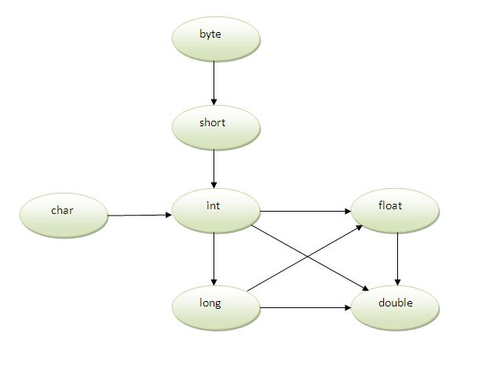
As displayed in the above diagram, byte can be promoted to short, int, long, float or double. The short datatype can be promoted to int,long,float or double. The char datatype can be promoted to int,long,float or double and so on.

Example of Method Overloading with TypePromotion
- class OverloadingCalculation1{
- void sum(int a,long b){System.out.println(a+b);}
- void sum(int a,int b,int c){System.out.println(a+b+c);}

- public static void main(String args[]){
- OverloadingCalculation1 obj=new OverloadingCalculation1();
- obj.sum(20,20);//now second int literal will be promoted to long
- obj.sum(20,20,20);

- }
- }
Test it Now
Output:40
60

Example of Method Overloading with Type Promotion if matching found
If there are matching type arguments in the method, type promotion is not performed.
- class OverloadingCalculation2{
- void sum(int a,int b){System.out.println("int arg method invoked");}
- void sum(long a,long b){System.out.println("long arg method invoked");}

- public static void main(String args[]){
- OverloadingCalculation2 obj=new OverloadingCalculation2();
- obj.sum(20,20);//now int arg sum() method gets invoked
- }
- }
Test it Now
Output:int arg method invoked

Example of Method Overloading with Type Promotion in case of ambiguity
If there are no matching type arguments in the method, and each method promotes similar number of arguments, there will be ambiguity.
- class OverloadingCalculation3{
- void sum(int a,long b){System.out.println("a method invoked");}
- void sum(long a,int b){System.out.println("b method invoked");}

- public static void main(String args[]){
- OverloadingCalculation3 obj=new OverloadingCalculation3();
- obj.sum(20,20);//now ambiguity
- }
- }
Test it Now
Output:Compile Time Error

Java Copy Constructor
There is no copy constructor in java. But, we can copy the values of one object to another like copy constructor in C++.
There are many ways to copy the values of one object into another in java. They are:
- By constructor
- By assigning the values of one object into another
- By clone() method of Object class
In this example, we are going to copy the values of one object into another using java constructor.
- class Student6{
- int id;
- String name;
- Student6(int i,String n){
- id = i;
- name = n;
- }

- Student6(Student6 s){
- id = s.id;
- name =s.name;
- }
- void display(){System.out.println(id+" "+name);}

- public static void main(String args[]){
- Student6 s1 = new Student6(111,"Karan");
- Student6 s2 = new Student6(s1);
- s1.display();
- s2.display();
- }
- }
Test it Now
Output:
111 Karan
111 Karan

Copying values without constructor
We can copy the values of one object into another by assigning the objects values to another object. In this case, there is no need to create the constructor.
- class Student7{
- int id;
- String name;
- Student7(int i,String n){
- id = i;
- name = n;
- }
- Student7(){}
- void display(){System.out.println(id+" "+name);}

- public static void main(String args[]){
- Student7 s1 = new Student7(111,"Karan");
- Student7 s2 = new Student7();
- s2.id=s1.id;
- s2.name=s1.name;
- s1.display();
- s2.display();
- }
- }
Test it Now
Output:
111 Karan
111 Karan

Q) Does constructor return any value?
Ans:yes, that is current class instance (You cannot use return type yet it returns a value).

Can constructor perform other tasks instead of initialization?
Yes, like object creation, starting a thread, calling method etc. You can perform any operation in the constructor as you perform in the method.

Java static keyword
- Static variable
- Program of counter without static variable
- Program of counter with static variable
- Static method
- Restrictions for static method
- Why main method is static ?
- Static block
- Can we execute a program without main method ?
The static keyword in java is used for memory management mainly. We can apply java static keyword with variables, methods, blocks and nested class. The static keyword belongs to the class than instance of the class.
The static can be:
- variable (also known as class variable)
- method (also known as class method)
- block
- nested class

1) Java static variable
If you declare any variable as static, it is known static variable.
- The static variable can be used to refer the common property of all objects (that is not unique for each object) e.g. company name of employees,college name of students etc.
- The static variable gets memory only once in class area at the time of class loading.

Advantage of static variable
It makes your program memory efficient (i.e it saves memory).

Program of counter without static variable
In this example, we have created an instance variable named count which is incremented in the constructor. Since instance variable gets the memory at the time of object creation, each object will have the copy of the instance variable, if it is incremented, it won't reflect to other objects. So each objects will have the value 1 in the count variable.
- class Counter{
- int count=0;//will get memory when instance is created

- Counter(){
- count++;
- System.out.println(count);
- }

- public static void main(String args[]){

- Counter c1=new Counter();
- Counter c2=new Counter();
- Counter c3=new Counter();

- }
- }
Test it Now
Output:1
1
1

Program of counter by static variable
As we have mentioned above, static variable will get the memory only once, if any object changes the value of the static variable, it will retain its value.
- class Counter2{
- static int count=0;//will get memory only once and retain its value

- Counter2(){
- count++;
- System.out.println(count);
- }

- public static void main(String args[]){

- Counter2 c1=new Counter2();
- Counter2 c2=new Counter2();
- Counter2 c3=new Counter2();

- }
- }
Test it Now
Output:1
2
3

Restrictions for static method
There are two main restrictions for the static method. They are:

- The static method can not use non static data member or call non-static method directly.
- this and super cannot be used in static context.

Q) why java main method is static?
Ans) because object is not required to call static method if it were non-static method, jvm create object first then call main() method that will lead the problem of extra memory allocation.

Java static block
- Is used to initialize the static data member.
- It is executed before main method at the time of classloading.

Example of static block
- class A2{
- static{System.out.println("static block is invoked");}
- public static void main(String args[]){
- System.out.println("Hello main");
- }
- }
Test it Now
Output:static block is invoked
Hello main

Q) Can we execute a program without main() method?
Ans) Yes, one of the way is static block but in previous version of JDK not in JDK 1.7.
- class A3{
- static{
- System.out.println("static block is invoked");
- System.exit(0);
- }
- }
Test it Now
Output:static block is invoked (if not JDK7)
In JDK7 and above, output will be:
Output:Error: Main method not found in class A3, please define the main method as:
public static void main(String[] args)

There can be a lot of usage of java this keyword. In java, this is a reference variable that refers to the current object.

Usage of java this keyword
Here is given the 6 usage of java this keyword.
- this keyword can be used to refer current class instance variable.
- this() can be used to invoke current class constructor.
- this keyword can be used to invoke current class method (implicitly)
- this can be passed as an argument in the method call.
- this can be passed as argument in the constructor call.
- this keyword can also be used to return the current class instance.
Suggestion: If you are beginner to java, lookup only two usage of this keyword.

Rule: Call to this() must be the first statement in constructor.
- class Student15{
- int id;
- String name;
- Student15(){System.out.println("default constructor is invoked");}

- Student15(int id,String name){
- id = id;
- name = name;
- this ();//must be the first statement
- }
- void display(){System.out.println(id+" "+name);}

- public static void main(String args[]){
- Student15 e1 = new Student15(111,"karan");
- Student15 e2 = new Student15(222,"Aryan");
- e1.display();
- e2.display();
- }
- }
Test it Now
Output:Compile Time Error

The this keyword can be used to invoke current class method (implicitly).

4) this keyword can be passed as an argument in the method.
The this keyword can also be passed as an argument in the method. It is mainly used in the event handling. Let's see the example:
- class S2{
- void m(S2 obj){
- System.out.println("method is invoked");
- }
- void p(){
- m(this);
- }

- public static void main(String args[]){
- S2 s1 = new S2();
- s1.p();
- }
- }

5) The this keyword can be passed as argument in the constructor call.
We can pass the this keyword in the constructor also. It is useful if we have to use one object in multiple classes. Let's see the example:
- class B{
- A4 obj;
- B(A4 obj){
- this.obj=obj;
- }
- void display(){
- System.out.println(obj.data);//using data member of A4 class
- }
- }

- class A4{
- int data=10;
- A4(){
- B b=new B(this);
- b.display();
- }
- public static void main(String args[]){
- A4 a=new A4();
- }
- }
Test it Now
Output:10

6) The this keyword can be used to return current class instance.
We can return the this keyword as an statement from the method. In such case, return type of the method must be the class type (non-primitive). Let's see the example:

Syntax of this that can be returned as a statement
- return_type method_name(){
- return this;
- }

Example of this keyword that you return as a statement from the method
- class A{
- A getA(){
- return this;
- }
- void msg(){System.out.println("Hello java");}
- }

- class Test1{
- public static void main(String args[]){
- new A().getA().msg();
- }
- }
Test it Now
Output:Hello java

Proving this keyword
Let's prove that this keyword refers to the current class instance variable. In this program, we are printing the reference variable and this, output of both variables are same.
- class A5{
- void m(){
- System.out.println(this);//prints same reference ID
- }

- public static void main(String args[]){
- A5 obj=new A5();
- System.out.println(obj);//prints the reference ID

- obj.m();
- }
- }
Test it Now
Output:A5@22b3ea59
A5@22b3ea59

